

press release
(English translation)

ECOMONDO 2024 STARTS TODAY: ITALY AT THE FOREFRONT OF THE INTERNATIONAL GREEN TRANSITION

- Gilberto Pichetto Fratin, Italian Minister of Environment and Energy Security, at the Opening Ceremony: “Ecomondo offers a privileged vantage point for the national economy”.
- Fabrizio Lobasso, Italian Ministry of Foreign Affairs and International Cooperation: “We are proud of the value Italy brings to the world, with Ecomondo serving as a key platform for connection, dialogue, and new opportunities”.
- A record-breaking milestone for Ecomondo 2024: 166,000 square metres of exhibition space, over 1,600 exhibitors and participants from more than 100 countries.
- The 13th edition of the States General of the Green Economy is officially underway: Achievements and challenges on the agenda.

Rimini, 5th November 2024 – The 27th edition of Ecomondo officially opened this morning. The international trade fair dedicated to the green and circular economy, organised by Italian Exhibition Group (IEG), runs at the Rimini Exhibition Centre from 5th to 8th November.

With over 1,600 exhibiting brands, buyers from more than 100 countries, and 72 international organisations, institutions, and trade associations, this event showcases a global commitment to sustainability. The exhibition space has been expanded with two new pavilions, constructed to meet strong demand, and hosts an extensive programme of over 200 meetings, conferences, and workshops coordinated by Ecomondo’s Scientific Technical Committee.

In his opening remarks at the Inauguration Ceremony, Maurizio Renzo Ermeti, President of IEG, highlighted: “Ecomondo’s journey, which began as Ricicla in 1997, has been one of remarkable growth and success, establishing itself as the leading annual gathering for the green and circular economy. Today, Ecomondo provides an unparalleled international platform that brings together industries, stakeholders, policymakers, researchers, institutions, companies, and associations, all united by a shared commitment to environmental sustainability”.

Fabio Fava, President of Ecomondo's Scientific Technical Committee, stated: “This year’s programme of conferences, workshops, and events places Ecomondo at the forefront of the international dialogue on the most pressing issues related to the ecological transition and technological solutions required for its European and global implementation. The Scientific Technical Committee, with support from experts and institutions such as the European Commission, the European Environment Agency, FAO, and the OECD, continues to provide guidance to enterprises across primary, secondary, and tertiary sectors engaged in this transition, who come together at Ecomondo, a true laboratory of knowledge and innovation.”

Fabrizio Lobasso, Deputy Director General for the Promotion of the Country System and Principal Director for Economic Internationalisation of the Italian Ministry of Foreign Affairs and International Cooperation, noted: “Ecomondo’s international reach aligns seamlessly with the strengths of Italian companies driving ecological and digital transitions. These companies bring quality and innovation to global markets, advancing sustainability goals and providing valuable resources for other countries at the international level. We are proud of the value Italy brings to the world, with Ecomondo serving as a key platform for connection, dialogue, and new opportunities.”

Italian Minister of Environment and Energy Security Gilberto Pichetto Fratin concluded the Opening Ceremony by confirming: “Ecomondo offers a privileged vantage point for the national economy. Here, we see Italy at the forefront of the ecological transition, with a strong focus on decarbonisation, efficiency, sustainable resources use, and production innovations. To achieve our climate targets, soon to be discussed at COP29, we need the powerful momentum of Italy’s green economy and successful models like recycling, which we will continue to advocate on every platform”.

Present at the ribbon-cutting ceremony for the 27th edition of Ecomondo were Anna Montini, Councillor for Ecological Transition, Rimini Municipality; Irene Priolo, Acting President of Emilia-Romagna Region; Corrado Peraboni, CEO of IEG; Alessandra Astolfi, Global Exhibition Director, Green & Technology Division, IEG; and Mauro Delle Fratte, Exhibition Manager of Ecomondo.

Among the key highlights of Ecomondo, the 13th edition of the States General of the Green Economy, organised by the National Council for the Green Economy and the Sustainable Development Foundation, in collaboration with the Ministry of the Environment and the European Commission. The 2024 Report on the State of the Green Economy, presented this morning at Ecomondo, provides an up-to-date overview of both Italian and international progress and challenges in critical areas such as decarbonisation, circular economy, and energy efficiency. In particular, Italy confirms a reduction in CO₂ emissions by over 6% (the most significant decrease in decades), leadership in the circular economy (€3.6 of GDP for every kg of resources consumed), and a rise in organic farming. Persisting challenges, such as soil use and sustainable mobility, are among the key topics for discussion and innovation at Ecomondo.

PRESS CONTACT - ITALIAN EXHIBITION GROUP
head of media & corporate communication: Elisabetta Vitali; press office manager: Marco Forcellini, Pier Francesco Bellini; international press office coordinator: Silvia Giorgi; press office coordinator: Luca Paganin; press office specialists: Nicoletta Evangelisti, Mirko Malgieri; media@iegexpo.it

MEDIA AGENCY:
Hill & Knowlton
Francesca De Angelis, +39 342 7460159 - francesca.deangelis@hillandknowlton.com
Valentina Corsi - +39 3270425730 - valentina.corsi@hillandknowlton.com
Alessio Ricciuto - alessio.ricciuto@hillandknowlton.com

Stampa Estera - Oksana Smirnova - smirnova.consultant@hillandknowlton.com

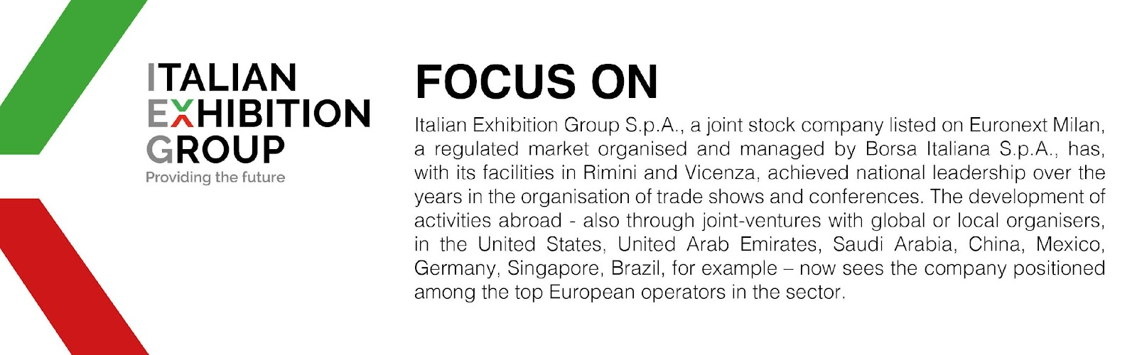

This press release contains forecast elements and estimates that reflect the management’s current opinions (“forward-looking statements”), particularly regarding future management performance, realization of investments, cash flow trends and the evolution of the financial structure. For their very nature, forward-looking statements have a component of risk and uncertainty, as they depend on the occurrence of future events. The effective results may differ (even significantly) from those announced, due to numerous factors, including, only by way of example: food service market and tourist flow trends in Italy, gold and jewellery market trends, green economy market trends; the evolution of raw material prices; general macroeconomic conditions; geopolitical factors and evolutions in the legislative framework. Moreover, the information contained in this release does not claim to be complete, and has not been verified by independent third parties. Forecasts, estimates and objectives contained herein are based on the information available to the Company as at the date of this release.

